CWWS Fund
Project Name:  144th Street Lift Station & West Bypass | Department:  Public Works - Utilities
Type of Project:  New Construction | Contact:  Chuck Soules
Total Project Cost:
$5,110,000

Description:
The 144th Lift Station is a planned pump station that will be located along 144th Street just east of Highway 169. With an updated system of gravity sewers, this pump station will collect wastewater from the surrounding area and convey the flow to the wastewater treatment plant by way of the South Force Main. The addition of this pump station, and associated piping, will consolidate the flows from multiple existing pump stations into a single route, allowing Diversified Metal, McDonalds, Platte Valley Bank, and Hills of Shannon pump stations to be decommissioned. This pump station will be sized to allow for additional capacity in the area and will provide the needed capacity to provide for future developments. In FY2025 the City expensed $110,000 to Evergy for improvements to the electrical infrastructure to the 144th Street Lift Station and $500,000 in project costs.

The construction will include a new lift station, pumps, and a SCADA (Supervisory Control and Data Acquisition) system.

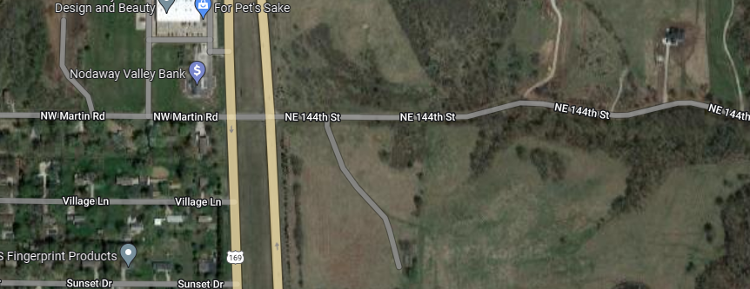
Justification:
The project is needed for capacity improvements in the southern portion of Smithville and will allow staff to decommission lift stations that are under capacity.

Impact on Operating Costs
This will be a new lift station which will require future maintenance and operational costs.

Planned Expenditures
 | FY2026 | Total
Construction | $4,500,000 | $4,500,000
Total | $4,500,000 | $4,500,000

Funding Sources
 | FY2026 | Total
CWWS | $4,500,000 | $4,500,000
Federal Earmark | ($1,500,000) | ($1,500,000)
Total Net Cost | $3,000,000 | $3,000,000

